Customer Bill of Exchange Payment

S.NO. : 02- FI-AR- 06

TRANSACTION CODE : F – 36

ACCESS PATH :SAP Easy Access Accounting Financial
Accounting Accounts Receivable Document Entry
Bill of Exchange Payment

We get “ Bill of exchange Payment – Header Data” Screen as under;

Required Fields:

Document Date : To be entered
Customer Account : To be entered
Spl. G/L Ind. : To be entered as “B” (Bill of exchange Receivable)
Posting date : Default

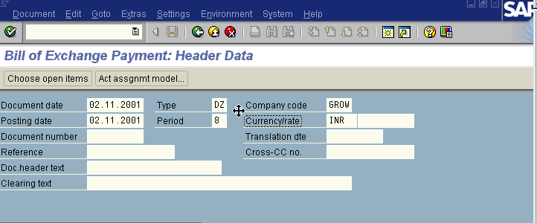
Document Type, Currency, Period & Company code appear as default after it has been entered for the first time.
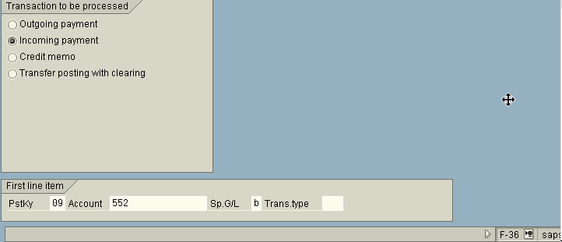
Press enter Button

We get “Bill of Exchange Payment – Add Customer Item” Screen as under

In the above screen fill the amount and due on fields

Press Enter

We get “Bill Of Exchange Payment- Correct Customer Item” Screen
As under
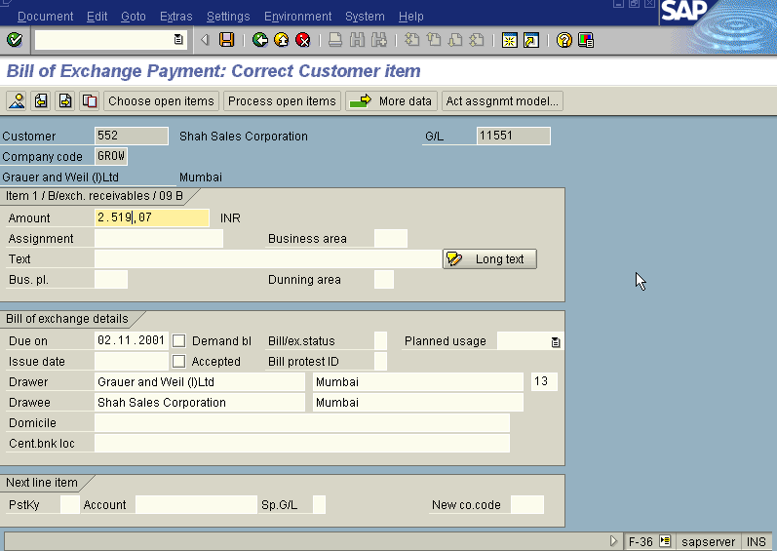

Press Save Button

We get “ Bill of Exchange Payment – Select Open Item” Screen as Under

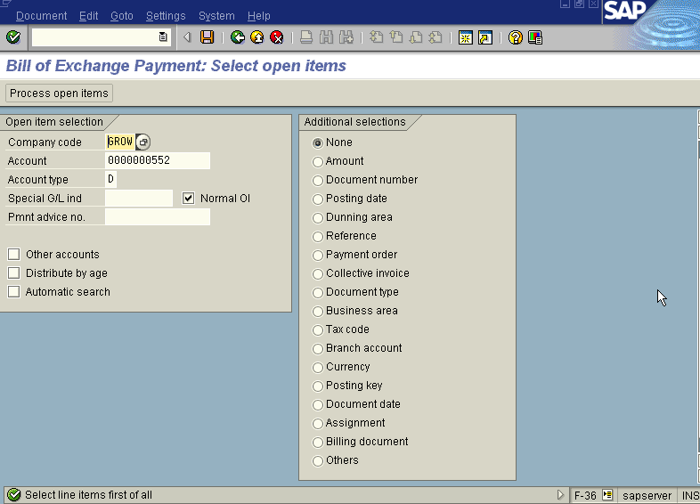

In the above screen Press Process Open Item button

We get “Bill Of Exchange – Process Open Item” Screen as Under
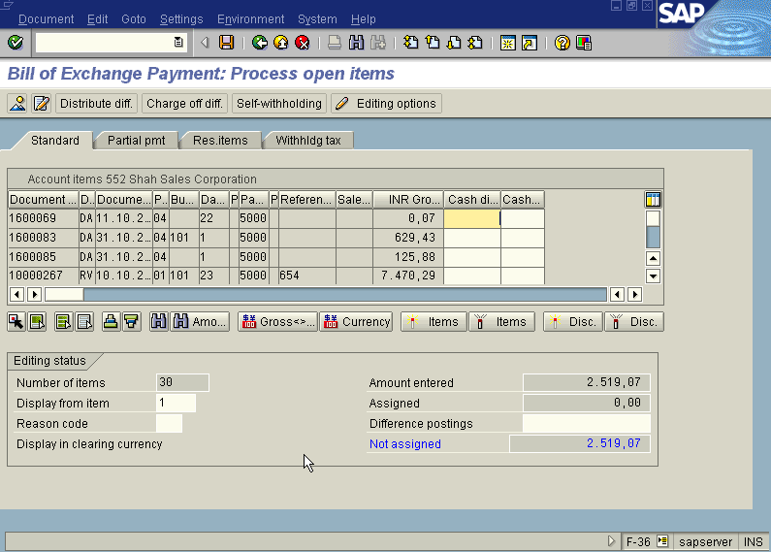

In the above screen first select all Icon, So all the line items will turn blue then press Deactivate Icon so that all the items turn black. Then select the document by scrolling the screen. Once you have found the Document double click on the amount field of that document. Then the Not Assigned field in the above screen turns Zero.

Press Save Button

The system displays the message as under

Take the note of the document number : 1400097.

To view the entries posted go to “Bill of Exchange Payment – Header data” screen
And click Document Display or press Transaction Code FB03.

We get the Overview document screen with the entries as under
